ARW Project Specs

Ansay, Lao, Sy, Tay, Villaroman

# Front End (Confirmed Views)

1. Welcome Page



1. Registration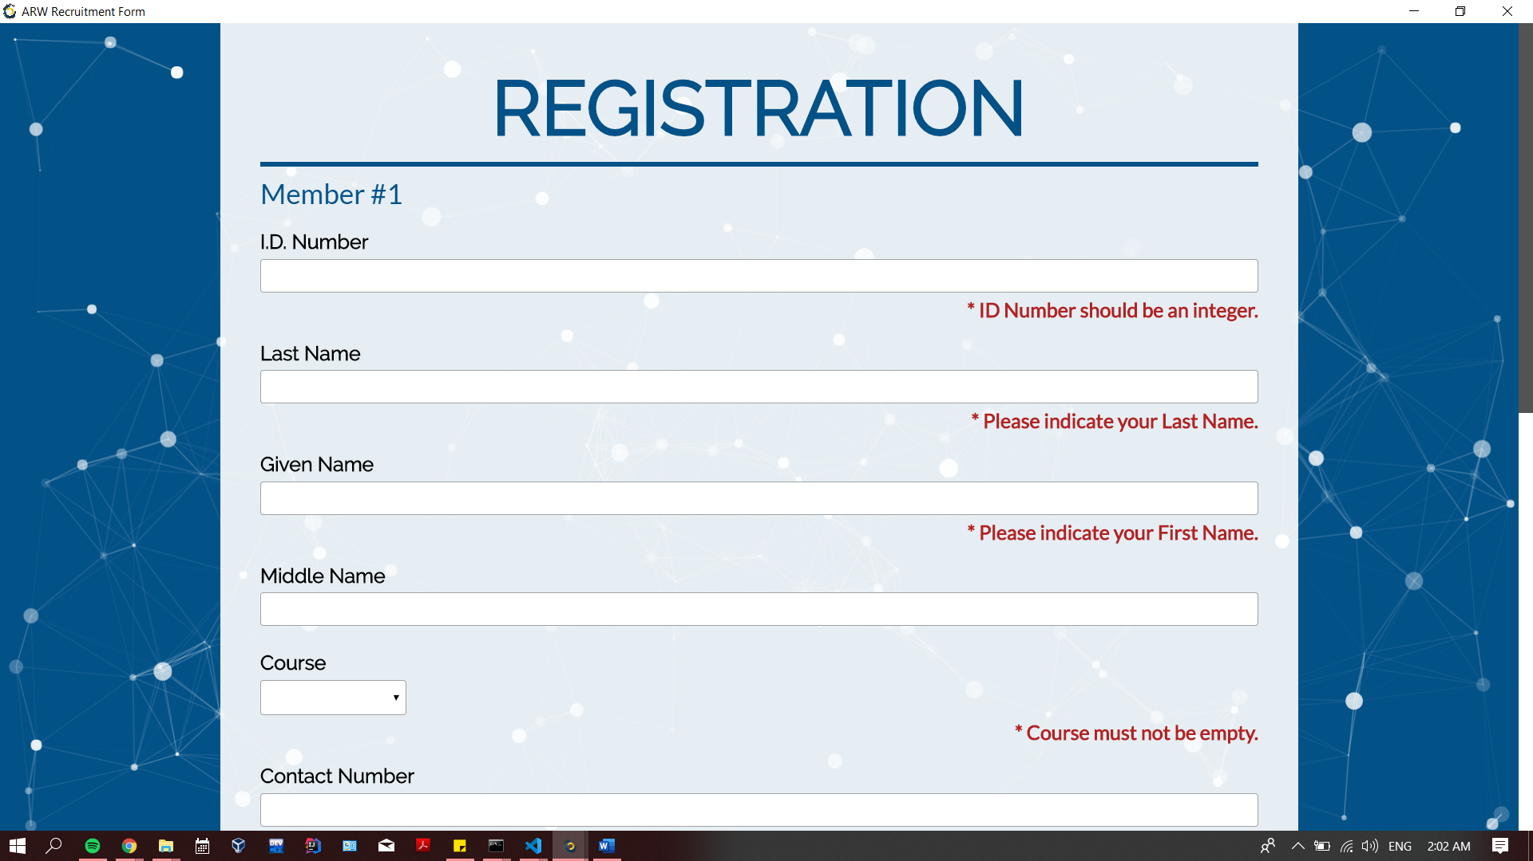

* consider how to differentiate the different sign-up types: Honorary, Group of 5 New Members, Group of 5 Old Members, New Member, Old Member

1. ID Number
2. Last Name
3. Given Name
4. Middle Name
5. Course
   1. "BSCS", "BSIT", "BSCS-ST", "BSCS-NE", "BSCS-IST", "BSCS-CSE", "BS-INSYS", "IET-GD2", "IET-AD2", "IET-GDS", "IET-ADS", "CSS", "BSMSCS", others
6. Contact Number +63 ____________
7. Facebook Name
8. DLSU Email
9. Are you an officer?
10. RECEIPT NUMBER
11. Dashboard/Members
    1. List of all members with ff filters:
       1. By Day
       2. Year
       3. Officer
       4. Junior Officer
       5. Old or new
       6. Single or taken (para kay Nicolas)
    2. Specific Member
       1. Edit
12. Dashboard/Accounting
    1. Honorary, Group of 5 New Members, Group of 5 Old Members, New Member, Old Member quantity and total earning with ff filters:
       1. For each day
       2. For the entirety

# Functionalities (* denotes not sure)

1. Online Database
   1. Add
   2. View
   3. Edit*
   4. Delete*
2. Export list of members to CSV, XLSX
   1. With or without filters*
3. Export accounting total to CSV, XLSX
4. Heroku with many clients
5. Chart JS*
6. Pano kung walang internet*
7. Accounting should only be accessed by people with credentials*